Blue Prism
Login Agent User Guide

December 2013

The information contained in this document is the proprietary and confidential information of Blue Prism Limited and should not be disclosed to a third party without the written consent of an authorised Blue Prism representative. No part of this document may be reproduced or transmitted in any form or by any means, electronic or mechanical, including photocopying without the written permission of Blue Prism Limited
© Blue Prism Limited, 2001 - 2013
All trademarks are hereby acknowledged and are used to the benefit of their respective owners.

Published by:
Blue Prism Limited
Centrix House
Crow Lane East
Newton-le-Willows
WA12 9UY, UK
Registered in England; Reg. No. 4260035
www.blueprism.com
Tel: 0870 879 3000

Contents
1 Introduction 5
1.1 Overview 5
1.2 Prerequisites 6
1.3 Blue Prism Installation 6
1.4 Distributable Files 6
2 Installation 7
2.1 Welcome 7
2.2 Connection Name 7
2.3 Installation Path 8
2.4 Confirm 8
2.5 User Account Control 9
2.6 Progress / Complete 9
2.7 Configuration / Restart 9
3 Architecture 10
3.1 Overview 10
3.2 Description of login/logout using Login Agent 10
3.2.1 After Login 11
3.2.2 Logging Out 11
4 Configuration 12
4.1 Login Agent Service 12
4.1.1 Leaving the connection empty 12
4.2 Logged On Blue Prism Resource 13
4.3 Login Agent Release 13
4.4 Logon Credential 13
5 Using Login Agent 14
5.1 Login Agent Processes 14
5.1.1 Login 14
5.1.2 Logout 14
5.1.3 Check Logged In 14
5.1.4 Change Password 14
5.2 Login Agent Actions 15
5.2.1 Get Credential Name 15
5.2.2 Lock Screen 15
5.2.3 Unlock Screen 15
5.2.4 Is Locked 15
5.2.5 Is Logged In 15
6 Troubleshooting 16
6.1 Resource stuck on error message: "Incorrect password or username" 16
6.2 No Resource started for machine before logon 16
6.3 Windows XP or earlier fails to boot 16
6.4 Windows XP fails to log on; No error is given 16
6.5 Resource PC takes a while to start after logon 17
6.6 Diagnostic Information 17

Introduction

Overview
Blue Prism is a robotic automation platform that enables organisations to automate business processes using existing desktop configurations on virtualised infrastructure.
Blue Prism processes are executed autonomously in a closed virtual machine environment with no direct user interaction.
In order for the Blue Prism processes to execute securely, the software must operate within a logged on Microsoft Windows session.
In order to facilitate this, Blue Prism provide a Login Agent capability, which uses documented Microsoft Windows APIs and methods to:
- Generate, encrypt and regularly update random secure domain passwords for the robot VMs that are not known outside the system
- On Windows start-up, authenticate the resource, and programmatically login to Windows using the decrypted generated password
- On process iniation, programmatically unlock the Windows desktop
- On process completion, programmatically lock the Windows desktop
The Login Agent component provides this mechanism utilising either the GINA architecture for Windows XP and below, or the Credential Provider API for Windows Vista and above, for secure and autonomous process execution without risk of manual intervention.
The Login Agent component also adds Blue Prism processes and business objects which allow the querying of the currently logged on state and the locked state, and provides functionality to change those states - i.e. to log on, log off, lock the screen and unlock the screen.
The usernames and passwords used to authenticate with windows are stored securely as credentials within the Blue Prism environment, using either the inbuilt 3DES encryption algorithm or optional, external mechanisms such as hardware encryption.
This document guides the new user through the process of installing the Blue Prism Login Agent software, and gives some guidance on running and troubleshooting the software afterwards.
In case of difficulty, please contact Blue Prism Support, either by email at support@blueprism.com or by telephone on 0870 879 3000.

Prerequisites
O/S: For 32-bit, Windows XP or later Windows operating systems; For 64-bit, Windows Vista or later Windows operating systems
Blue Prism: v4.1.25 or higher. This document assumes that the machine on which the Login Agent is to be installed already has a fully operating Blue Prism environment installed and configured.
User access: Administrator access is required on the target system
Security Policies: Certain group policies can cause the Login Agent to be unable to log in correctly. The following policies in "Local Policies" / "Security Options" should be configured as specified:
- "Interactive logon: Do not require CTRL+ALT+DEL" : Enabled (not necessary for installations on Windows XP)
- "Interactive logon: Message title for users attempting to log on" : Empty
- "Interactive logon: Message text for users attempting to log on" : Empty
The installer sets the above local policies, but if they are defined differently at domain or organisational unit level, any changes made by the installer will be overridden and the Login Agent will not work.
Other Requirements: The GINA implementation used in Windows XP requires that the default logon screensaver is deactivated. This can be done by setting the value “0” into the registry value at:
HKEY_USERS\.DEFAULT\Control Panel\Desktop\ScreenSaveActive
The installer performs this operation, also; it is here for reference if the setting is overridden at any point.

Blue Prism Installation
A full guide to the installation of the Blue Prism application is available from Blue Prism. This will give further prerequisites required for a working Blue Prism deployment.

Distributable Files
Two installers are available to install the Login Agent software – one to be used for 32 bit environments; the other for 64 bit environments. It is essential that the correct one is used for the target system. The files are named:-
- LoginAgentSetup32.msi – 32 bit setup
- LoginAgentSetup64.msi – 64 bit setup

Installation
Log on to the target system and copy the appropriate installer into a local folder. Double click it to begin the installation.

Welcome
On running the installer, the welcome page is displayed. Click Next to continue.
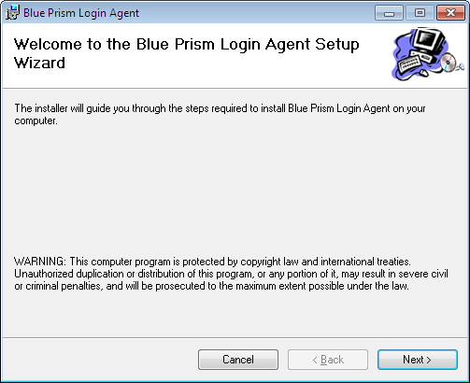

Connection Name
This page accepts the name of the Blue Prism connection which should be used on this PC. The name should correspond to one of the connections defined in the installed Blue Prism software. If left blank, it will not be created or changed in this install.
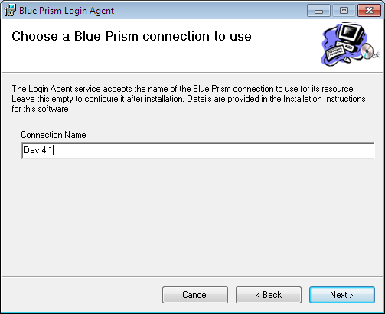

Installation Path
The next page allows you to choose where on the hard drive the program should be installed. Select the desired folder path and press “Next”.
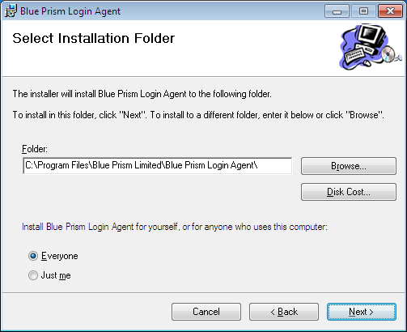

Confirm
The confirmation screen will show before the files are copied. Press Next to copy the files.
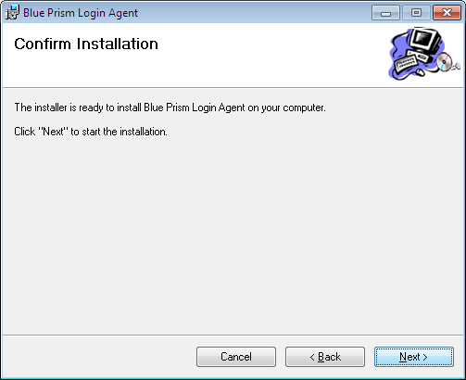

User Account Control
Windows will request administrator access to continue with the installation. You may have to enter an administrator username and password if you are not logged on as administrator. Click “Yes” to continue.
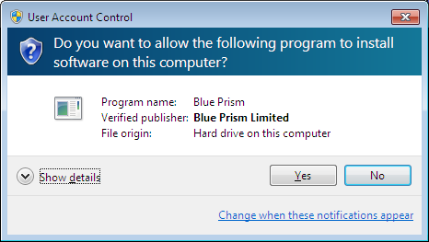

Progress / Complete
The installer should now run to completion. If the installer detects a missing prerequisite (e.g. a Blue Prism version before 4.1.25 is installed, or an attempt is made to install the 64 bit Login Agent on a Windows version before Vista), it will display a warning from which you can choose to continue or cancel the installation.

Configuration / Restart
Further configuration may be necessary. See Configuration for more details about configuring Login Agent. Once configuration is complete, a restart of the machine will ensure that the Login Agent Service is running.

Architecture

Overview
On booting a resource with the Login Agent Service enabled, a resource PC is executed in a system session. This resource PC is limited - e.g. it cannot drive programs which interact with the user desktop directly. Though it is connected to the wider Blue Prism environment, it is designed largely to execute the processes defined in the Login Agent Release.
When a user session begins, either through the Login Agent or directly, the system resource PC is shut down and the service effectively goes on standby until the user session finishes.
Meanwhile, the resource PC configured in the user's Startup settings is created within the user session. This is a normal resource PC which can interact with any programs available to the user.
When the user session ends, the user resource PC is closed along with all of the other user programs and the service starts a new resource PC in the system session.

Description of login/logout using Login Agent
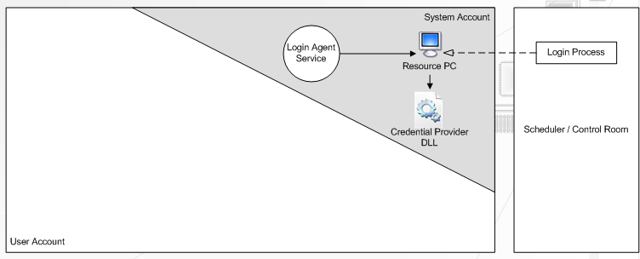
Before Login

Figure 1 - Before Login
On boot, the login agent service starts and runs a Resource PC in the system account. This has no access to user programs.
Either from the scheduler or Control Room within a Blue Prism client, a 'Login Process' is created and run on the resource PC. This connects to the logon component (credential provider or BP Gina) with retrieved login credentials and logs into Windows.

After Login
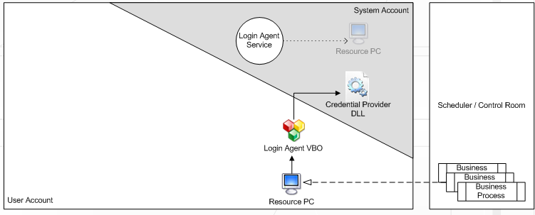
Figure 2 - After Login
After a successful login, the system account resource PC is closed. The VM is configured to start a resource PC on login - this will operated within the user account and so will have access to the desktop and user programs to be automated. Sessions can be created and executed on it in the usual manner.
The 'Login Agent' VBO is available to enable the VM's screen to be locked and unlocked using the stored login credentials.

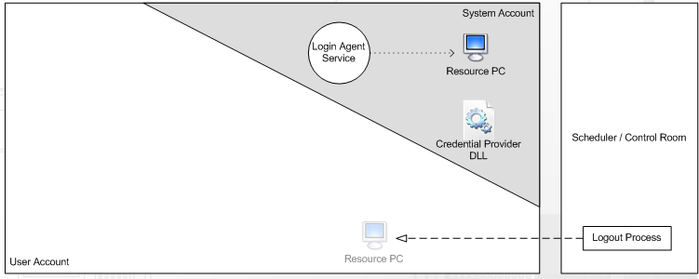
Logging Out

Figure 3 - Logging Out
A "Logout Process" is created and run on the user account resource PC while the VM is still logged in. This process will instruct Windows to log out. In doing so, the resource PC is closed down with all other user account applications.
The Login Agent service detects that the user has logged out and starts the resource PC in the system account to await the login process instructing the VM to login once more.

Configuration

Login Agent Service
The “Blue Prism Login Agent” service is installed and configured to run automatically on boot. It can be started or stopped from the Windows Services administrative tool.
It uses a configuration file to hold the Blue Prism software working directory and the arguments which should be used to start the resource PC it maintains before log on. The file is located at:
C:\ProgramData\Blue Prism Limited\Automate V3\LoginAgentService.config
If the file is not there, it can be created by starting and stopping the service. A typical file looks like:
<?xml version="1.0" encoding="utf-8"?>
<configuration>
<workingdirectory path="C:\Program Files\Blue Prism Limited\Blue Prism Automate\" />
<startuparguments>
<argument name="resourcepc" />
<argument name="public" />
<argument name="port">
<value>8001</value>
</argument>
<argument name="dbconname">
<value>Dev 4.1</value>
</argument>
</startuparguments>
</configuration>
The workingdirectory element points to the installation directory for the Blue Prism software. The startuparguments element gives the arguments to pass to the Automate program to start the resource PC before Windows is logged on. For example, the above configuration indicates that the command line to start the resource PC should be
"C:\Program Files\Blue Prism Limited\Blue Prism Automate\Automate.exe" /resourcepc /public /port 8001 /dbconname "Dev 4.1"
If any other arguments are required for the pre-logon resource, they should be added here in a similar fashion. For example, to add a DB password for a SQL Server authenticated database add the XML:
<argument name="setdbpassword">
<value>Password$123</value>
</argument>
… before the closing </startuparguments> tag.
Note: The setdbpassword will only work in Blue Prism versions v4.2.18 and above.

Leaving the connection empty
Note that if no connection is specified in the configuration file (using the dbconname argument), the first database connection specified in the connection list in Blue Prism will be used.

Logged On Blue Prism Resource
A Blue Prism resource PC needs to be configured to run on Windows logon to allow for the normal handling of processes within the Blue Prism environment. This can be done by creating a shortcut to Automate.exe in the logon user’s Startup directory (typically in "%USERPROFILE%\Startup") with the appropriate command line arguments configured in it.
These arguments typically mirror those specified in the Login Agent service’s configuration file.

Login Agent Release
The actual logging on and off and locking of the screen is done via Blue Prism processes. These are installed alongside the Login Agent software in the install directory - by default, this is at C:\Program Files\Blue Prism Limited\Blue Prism Login Agent. The release file is called Login Agent Release.bprelease, and it can be imported into any Blue Prism environment using Release Manager, or the File|Import menu option within the Blue Prism client.

Logon Credential
Each resource configured with the Login Agent software will require a credential defined in the Blue Prism environment to hold its logon credentials. The format of the credential used by the Login Agent processes is defined in the 'Get Credential Name' action within the 'Login Agent' VBO. The default format used by the VBO installed in the Login Agent Release is: "Windows Login: {MachineName}" where {MachineName} is replaced by the name of the machine on which the process is running. E.g. for a logon process running on a resource UKPCS003:8001 where UKPCS003 is the name of the machine and the resource is running on port 8001, the credential that the process will look for to log onto Windows with is "Windows Login: UKPCS003"

Using Login Agent

Login Agent Processes
A number of processes are included in the Login Agent Release, distributed with the software. Many of them require a credential to be configured for each resource hosting the Login Agent. See the Logon Credential configuration section for more details.

Login
Designed to be sent to the system resource PC operated by the Login Agent service. This will use the credential for the resource as defined in the Logon Credential configuration section to log onto Windows. It can be used to log into a local Windows account or into a domain; the parameter 'Login Locally' determines which of the two options to choose. The default choice, if no value is assigned to the startup parameter, is to log into a local Windows account. The domain can be specified too – if not, it will use the domain set in the current windows environment.
Note that this process will be successful even if the logon is ultimately unsuccessful - it returns after sending the message to log on with the supplied credentials.

Logout
Designed to be sent to the user resource PC operated within the user session. This will close all programs in the user session and log out of windows. An optional delay can be passed in as the parameter 'Delay' which will hold off from logging out for the time specified. The process will still complete immediately, and the session will logout after the delay has passed.

Check Logged In
Can be sent to either the user or system resource PC, it checks the current state of the resource. It is designed to be executed from Control Room, in which the log can be checked to determine the logged in state of the resource.

Change Password
Designed to be sent to the user resource PC, this process will terminate immediately if sent to the system resource PC. It generates a new password in the credential for the resource as defined in the Logon Credential configuration section, and then configures Windows to use the new password. If the password change in Windows fails, the credential is reverted to its previous value and the process is terminated.
The parameters defining what characters to allow in the passwords can be modified in the appropriate data items defined within the process.

Login Agent Actions
Along with the Login Agent processes described above, the Login Agent release contains the Login Agent Visual Business Object which is used by the included processes, and can be used by other processes where appropriate.
There are a few published actions which are available for use in processes, though most are there to support the above Login Agent processes. The following are designed for use in user processes running inside the user session resource PC.

Get Credential Name
Retrieves the name of the credential which serves the running resource. This can be used to retrieve the credential to use in order to, for example, unlock the screen.

Lock Screen
Locks the windows screen such that the desktop is no longer visible and authentication is required to re-enter windows proper. Has no effect if the screen is already locked.

Unlock Screen
Unlocks the currently locked screen. Requires 2 arguments :
- Password: The current password for the current logged on user on the resource
- Local: Indicates if the user is a local Windows account or a domain account - this is necessary because the method of passing the credential differs between the two.

Is Locked
Checks if the resource is currently locked or not. Returns a single output parameter:
- Locked: True to indicate that the resource is logged on and locked; False otherwise.

Is Logged In
The VBO/Action equivalent of the Check Logged In process, this returns a single output parameter:
- Logged In: True to indicate that the resource is logged in and the process is running within the user session; False to indicate that it is not logged in and the process is running within the system session.

Troubleshooting

Resource stuck on error message: "Incorrect password or username"
If the credentials for a resource are incorrect within the Blue Prism environment, it cannot authenticate to Windows but Windows keeps attempting to resend the authentication and an error message displays repeatedly. The only way to get around this is to reboot the resource.
Once rebooted, the logon prompt should be displayed again. If the correct password is unknown, log on as an administrator and reset the password for the affected user, then update the appropriate credential in Blue Prism System Manager.

No Resource started for machine before logon
If the resource does not start when the machine is awaiting logon and the connection used is a direct SQL authenticated connection, the database password will need to be set in the Login Agent configuration file. See the 4.1 section for more details on how to configure the service.

Windows XP or earlier fails to boot
If anything goes wrong in the logon handling for Windows XP, it can fail to boot fully. In this case, the only way to log in is to use the Recovery Console from an XP install CD ROM. See http://support.microsoft.com/kb/307654 for details on how to install and use the Recovery Console.
Once in the Recovery Console for the affected machine, the default logon process (ie. not using the Login Agent) can be re-enabled by replacing the Blue Prism GINA implementation with a copy of the default Microsoft implementation:
cd \windows\system32
del bpgina.dll
copy msgina.dll bpgina.dll
exit
This will then reboot into a normal Windows XP prompt. There should be a log file at C:\bpgina.log – please send this to Blue Prism Support (support@blueprism.com) to enable us to aid in diagnosing the problem and formulating a workaround.

Windows XP fails to log on; No error is given
The winlogon process for Windows XP times out and displays a screensaver after a few minutes of inactivity. If the screensaver is active, the Blue Prism GINA component cannot automate the logon.
For an immediate workaround, the VM can be woken up by moving the mouse on that machine. For a more permanent solution, the screensaver should be disabled on that machine by finding the registry key:
HKEY_USERS\.DEFAULT\Control Panel\Desktop\ScreenSaveActive
…and setting its value to “0”.

Resource PC takes a while to start after logon
In Control Panel, it can take a few minutes for the resource PC to start in ‘logged on’ mode, after successfully running a Login process and seeing the resource PC change colour to black in the display, indicating that the pre-logon resource has been closed.
This can occur because the logged on resource may start up while the pre-logon resource is still running and, if they are listening on the same network port, it will not be able to start fully until the pre-logon resource is closed. It will retry after two minutes, which is why it appears to take a while to start.
One way of improving this situation is by specifying, in the Login Agent Service configuration, that the pre-logon resource listens on one network port and having the logged on resource listening on a different port. This also means that you can instantly tell by looking in the resource viewer in Control Room whether a resource is logged in or not.

Diagnostic Information
Diagnostic information is logged to the “Application”, “System” and “Blue Prism” windows event logs, viewable and exportable using the ‘Event Viewer’ within Windows.
On Windows XP, an additional log file is stored, by default, at C:\bpgina.log. This location is overridable using the registry key:
HKEY_LOCAL_MACHINE\SOFTWARE\Blue Prism Limited\LoginAgent\LogFile
Note that the logfile will record an error when the Blue Prism Logon process drops its connection after sending the logon information. The error will read something like:
Error while reading from pipe: Last Error: 0x000003e5 (ERROR_IO_PENDING=0x000003e5)
This is normal behaviour and can be safely ignored.

